**National Institute of Technology**

**Raipur**



“DIGITAL IMAGE PROCESSING”

TEACHER ASSESSMENT ASSIGNMENT

**“Implement image segmentation of sample images using Gradient Vector Flow technique”**

|  |  |
| --- | --- |
| **Submitted to-** | **Submitted by-** |

Dr. Rekh Ram Janghel Anamika Raj (15118010)

Assistant Professor, Vyom Bani (15118071)

Department of Information Technology, Vineetha Reddy (15118071)

NIT, Raipur

**Table of Content**

1. Introduction -----------------------------------------------------------------------3
   1. Image segmentation
   2. Classification of image segmentation
   3. Materials used
2. Literature Review -----------------------------------------------------------------7
3. Methodology ----------------------------------------------------------------------9
   1. Algorithm
4. Experimental Results -----------------------------------------------------------12
5. Conclusion and Future work ---------------------------------------------------14

* References --------------------------------------------------------------------14

**“Implement image segmentation of sample images using Gradient Vector Flow technique”**

1. **Introduction**

The information which we see through our eyes are the most perceived knowledge “by the human” beings [1]. One-third part of human brain’s “cortical area” is dedicated to visual information processing.

“Digital image processing is a computer system-based technology, which carry out automatic processing, manipulation and interpretation of those visual information, where it plays an increasingly important role in many aspects of our daily life. It also includes a wide variety of disciplines and fields in science and technology, with applications such as medical diagnosis, elevision, photography, robotics, remote sensing, and industrial inspection [1] [2].”

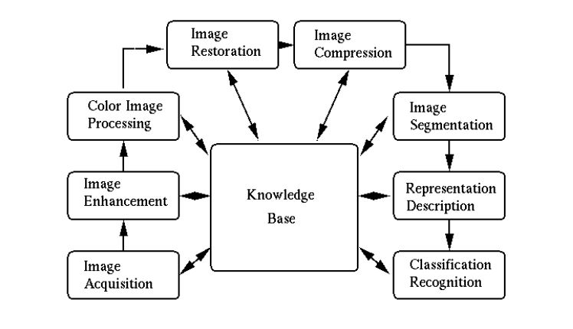

Figure 1: Steps involved in Image Processing [5]

Initially, pre-processing is done for “contrast enhancement before further processing [6]. Coming to the next step in image analysis which is segmentation. Color, shapes, patterns and texture are the basic features to segment the complex image into the simple objects for the human vision”. These images into different regions are called image segmentation. In the long run, the image representation is of so much importance that the image outcomes are very much important and functional for ongoing researches [6] [7] [9].

* 1. **Image Segmentation**

Since we all know Image segmentation is an important and very much challenging process of “image processing. It aims to section any digital image into a set of different regions where each and every pixel is uniform and as well as visually distinct with respect to some characteristics like boundary, texture, intensity, and color etc., to identify the objects’ boundaries in an image [4] [7]. This calculated partitioning is said to be domain independent. It provides those significant information which can easily be analysed [11] [12].”

* 1. **Classification of Image Segmentation Techniques**

“There are several different “techniques which are used” for the process of image segmentation. These all techniques have their own independent importance. These “techniques can be approached from two basic approaches of segmentation” where the first one is region based and the other is edge based approaches. Each and “every technique can be applied” on various “different images to perform” required image separation [7] [9].

These all methods can also “be classified into three categories” [14] :

A). “Structural Segmentation Techniques”: These techniques of image segmentation relies upon the structural infomation of required portion of the image means the required region which is going to be segmented [10].

B). “Stochastic Segmentation Techniques”: These techniques of image segmentation works on the discrete pixel values “of the image instead of the information” of structure of region [12].

C).” Hybrid Techniques”: These techniques of the image “segmentation uses the concepts of both of the above techniques” i.e. they use discrete structural information and pixel together [10].

Later on this paper, “various techniques of segmentation are discussed briefly” and compared. Mathematical description is to be avoided for simplicity and hence all the techniques are described theoretically. Some of the popular “techniques used for image segmentation” are: thresh holding method, region based techniques, edge detection “based techniques, clustering based techniques, watershed based techniques, partial differential equation based and artificial neural network based techniques etc”. These of the techniques are different from each other with respect to the method used by these for segmentation.”

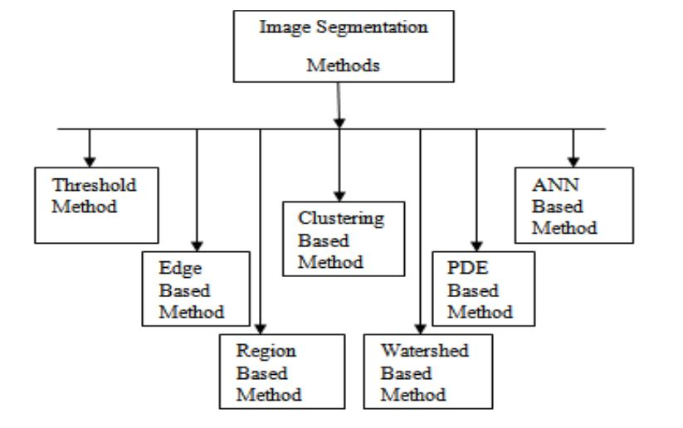

Figure 2: “Image Segmentation Methods”

* + 1. **Thresholding Method:**

“Thresholding methods are the “easiest and simplest” methods for image segmentation. This method divides the image pixels with respect to their “intensity level”. Images” having objects higher than the background are applied with thresholding method. Based on the prior information of the images, the selection of the methods are either manually or automatically. There are the basic three types of thresholding methods [11] [13].

* + 1. **“Edge Based Segmentation Method:”**

“The “edge based segmentation methods” are well developed techniques for image processing. When there is a rapid change in the concentration of the pixels in an image, rather than a single pixel, it give better results and the edges can be detected smoothly. This technique locates the edges whose first derivative of intensity is greater than a particular threshold or else the second derivative has zero crossings. In edge based segmentation methods, first of all, to segment a particular image, all the edges are joined together and forms a boundary. Some of the basic two edge based segmentation methods are as follows- Gradient based histograms and Grey methods. To detect the edges, these basic edge detection techniques such as “sobel operator”, “canny operator and Robert’s operator etc. are used. Result of these methods gives a binary image. These structural techniques are based on discontinuity detection [11]”.

* + 1. **Region Based Segmentation Method:**

This segmentation methods divides the image into different regions based on some similarities in each region. The related pixels of image are grouped for segmentation. The area detected for segmentation should be closed which are known as “Continuity Based”. In this method, first of all, assemblage of initial seed points are selected. Then, the similarity pattern is picked and then are put on impasse. Finally the region grows by annexation [11].

* + 1. **Clustering Based Segmentation Method:**

“The clustering based segmentation methods are the techniques that segment the image into the clusters having pixels with similar characteristics. Data clustering is that method that divides the elements into groups or clusters such that elements in same cluster the element are of same type than the data of the other type to each other. There are two types of clustering methods- Hierarchical method and Partition based method. These methods are based on the data structure known as tree. In this “method, “root of the tree represents whole database and the internal nodes represent the clusters. The other side of this represents the partition based methods which use optimization methods iteratively to minimize the “objective function” [14].

* + 1. **Watershed Based Methods:**

This method uses the concept of unique form of “topological interpretation”. In this method the intensity represents the regions having hole in its minima from where the water leaks. The adjacent basins are merger when water reaches the contour border. To maintain the separation between these regions dams are required which are the borders of region of “segmentation”. This method considers the image gradient as topographic surface. The pixels having gradient in dense number are represented as boundaries which are in continuous form [15].

* + 1. **Partial Differential Equation Based Segmentation Method:**

This method is the fast method of segmentation. There are two types of PDE- non-linear isotropic diffusion filter (which is used for edge enhancement) and convex non-quadratic variation restoration (which is used for removal of noise). The results of this method gives blurred edges and the boundaries that are shifted by using close operators [13].

* + 1. **“Artificial Neural Network Based Segmentation Method:”**

The “artificial neural network” segmentation method simulates the learning strategies of human brain for most intelligent decision making. These days this method is basically used for the segmentation of those of medical images. This method separates the contrasting regions from an image. This method is independent of Partial Differential Equation. This is neural network based problem solving technique. This method involves basic two steps which are i). Extracting features and ii). Segmentation by neural network [8].

Comparison of various “image segmentation techniques”-

|  |  |  |  |
| --- | --- | --- | --- |
| **Segmentation technique** | **Description** | **Advantages** | **Disadvantages** |
| **“Thresholding” Method** | based on the histogram peaks of the image to find particular threshold values | no need of previous information, simplest method | highly dependent on peaks, spatial details are not considered |
| **Edge Based Method** | based on discontinuity detection | good for images having better contrast between objects | not suitable for too many images and wrong detected contours. |
| **Region Based Method** | based on partitioning image into homogeneous regions | more immune to noise, useful when it is easy to define similarity criteria | This is an expensive with respect to time and memory |
| **Clustering Method** | based on division of clusters into various homogeneous clusters | Fuzzy uses the partial membership and hence are more useful for real problems | determining membership function is not easy |
| **Watershed Method** | based on the unique topological interpretation method | results are more stable, detected boundaries are continuous | complex calculation of gradients |
| **PDE Based Method** | based on the working of differential equations | fastest method, best for time critical applications | more computational complexity |
| **ANN Based Method** | based on the simulation of learning process for decision making | Avoids writing of complex problems | Training takes more time |

* 1. **Materials Used**

“Barkeley Segmentation Database is the dataset used in this paper. The goal of this method or say this method is to provide a good segmentation technique using gradient vector flow method. Up to this 12,000 hand-labelled segmentations of 1,000 Corel dataset images from 30 human beings have been collected.  Where half of the segmentations are obtained from color images; the other half from representing a grayscale image. Hence the public benchmark on this data consists of all of the grayscale and color segmentations for 300 images of this dataset. It consists of 200 training images and 100 testing images [5].”

**1.3.1. Gradient Vector Flow**

we gift a brand new category “of external forces for active contour models that addresses each issues listed on top of These fields, which we call gradient vector flow (GVF) fields are very dense vector fields which gets derived from images by minimizing a certain energy functional in a variational framework. The minimisation is achieved by determination a combine of decoupled linear partial differential equations that diffuses the gradient vectors of a grey-level or binary edge map computed from the image. We decision the active contour that uses the GVF field as its external force a GVF snake. The GVF snake is distinguished from nearly all previous snake formulations therein its external forces cannot be written because the negative gradient of a possible operate. Because of this, it cannot be developed victimisation the quality energy minimisation framework; instead, it's specified directly from a force balance condition.

$$ε=∬μ\left(u_{x}^{2}+ u_{y}^{2}+ v_{x}^{2}+ v_{y}^{2}\right)+|{∇f|}^{2}\left|v-{∇f|}^{2}\right|d$$

This variational formulation follows a regular principle, that of creating the result sleek once there's no knowledge. In particular, we see that when the image is small, the energy is dominated by sum of the squares of the partial derivatives of the vector field, yielding a slowly varying field. On the other hand, when the image is large, the second term dominates the integrand, and is minimized by setting. This results in getting the desired effect of keeping the threshold nearly equal to the gradient of the edge map when it is large, but forcing the field to be slowly-varying in homogeneous regions. The parameter is a regularization parameter governing the trade off between the first term and the second term in the integrand. This resultant parameter should be set according to the amount of noise present in the image (if the image is large, larger the parameter). We note that the smoothing term—the first term within the integrand —is the same term used by Horn and Schunck in their classical formulation of optical flow [21]. It has recently been shown that this term corresponds to associate equal penalty on the divergence and curl of the vector field [22]. Therefore, the vector field ensuing from this diminution will be expected to be neither entirely irrotational nor entirely solenoidal.”

1. **Literature Review**

|  |  |  |  |  |  |  |  |
| --- | --- | --- | --- | --- | --- | --- | --- |
| **S.No.** | **Author name** | **Publisher name** | **Paper title** | **Year** | **Methods** | **Result** | **Future scope** |
| **1.** | Steven D. Oberhelman [57] | University of Rhode Island | Active Contours Implementation | 2018 | Marr Mthod, Gradient Vector Flow, Vector field convolution | -- | biomedical image processing |
| **2.** | Rui Zhang [58] | Beihang University, Beijing, China | A Gradient Vector Flow Snake Model using Novel Coefficients Setting for Infrared Image Segmentation | 2016 | Gradient Vector Flow | 91.77% | Segmentation of infrared images for manufacturing |
| **3.** | [Oleg Michailovich](https://www.ncbi.nlm.nih.gov/pubmed/?term=Michailovich%20O%5BAuthor%5D&cauthor=true&cauthor_uid=17990755), Yogesh Rathi ,  Allen Tannenbaum [54] | [US National Library of Medicine](https://www.nlm.nih.gov/)  [National Institutes of Health](https://www.nih.gov/) | Image Segmentation Using Active Contours Driven by the Bhattacharyya Gradient Flow Top of Form  Bottom of Form | 2013 | Active Contours | 76.3% | Generalizing segmentation methods |
| **4.** | Li, Gang [48] | licensee BioMed Central Ltd. | 3D cell nuclei segmentation based on gradient flow tracking | 2007 | Gradient flow tracking | 77.8% | 3D microscopy imaging |
| **5.** | Wang, Li, [45] | Elsevier Ltd. | Active contours driven by local and global intensity fitting energy with application to brain MR image segmentation | 2009 | Local and global intensity fitting | 78% | Brain MR image segmentation |
| **6.** | Chunming Li, Rui Huang, Zhaohua Ding, J. Chris Gatenby, Dimitris N. Metaxas, Member [42] | licensee BioMed Central Ltd. | A level set method for image segmentation in the presence of intensity inhomogeneities with application to MRI | 2011 | Bias correction, image segmentation, intensity inhomogeneity, level set | 76.5% | bias correction of magnetic resonance (MR) images with promising results. |
| **7.** | Ko, Byoung Chul, Ja-Won Gim, and Jae-Yeal Nam | [US National Library of Medicine](https://www.nlm.nih.gov/)  [National Institutes of Health](https://www.nih.gov/) | Automatic white blood cell segmentation using stepwise merging rules and gradient vector flow snake | 2011 | mean-shift clustering and boundary removal rules with a GVF (gradient vector flow) snake | 76.6% | can solve a variety of challenging image segmentation problems |
| **8.** | Bradski, Gary R., and James W. Davis | Springer-Verlag 2002 [37] | Motion segmentation and pose recognition with motion history gradients | 2002 | Motion segmentation – Normal optical flow | 72% | computationally faster than other motion segmentation algorithms based on optical flow. |

1. **Methodology**

“Active contour model which are called snakes, is a “framework for obtaining an object outline for a given image”. This framework attempts to minimize the energy associated with the current contour as a formula of sum of an internal and external energy [25].

When the snake is at boundary position then the external energy associated with the image is minimum. One of the most significant approach consists in putting low values when the regularized gradient around the contour position reaches its peak value [25] [26].

“The internal energy is said to be minimal when the gradient snake takes a shape which is supposed to be relevant considering the shape of the called object”. One of the most straightforward approach grants high energy to the elongated contours called elastic force and to bended and high curvature contours called rigid force, considering the shape should be regular and as well as smooth as much as possible [30] [32].

E(snake)= ∫ E internal(v(s)) + E external(v(s)) ds

“E internal = α * (dv/ds) + β * (d^2(v)/d(s^2))”

E external = wl*E line + we*E edge + wt*E term

## Steps for the given method-

 1. Compute the absolute difference i.e. L2 difference in case of colour images, of source image patch and destination image region. This is to retain the salient features of both the source and destination image patches.

 2. Initialize snake at the boundary specified by the user. The weights for the internal and external energy functions are set appropriately so that the snake can easily deform and align with the edges/boundaries of the salient features.

 3. Iteratively deform the snake to minimize its energy. The final snake position should give us the optimal boundary for Poission image editing.

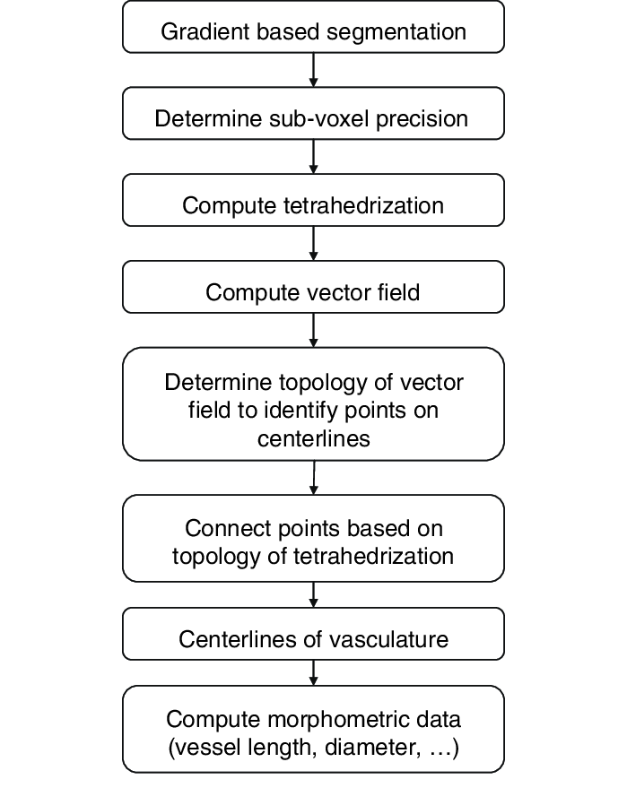

Figure 3: Dataflow diagram of GVF

The equation for the “diffused gradient vector field **v**(*x*, *y*)= (*u* (*x*, *y*), *v* (*x*, *y*,) (*u* (*x*, *y*), *v* (*x*, *y*) and are two components of the diffused gradient vector projecting to *x*, *y* and *z* axis respectively) in a 2D image is defined to be a solution to the partial differential equation (PDE), also known as a Navier-Stokes equation, describing the deformation of an elastic sheet [[13](https://bmccellbiol.biomedcentral.com/articles/10.1186/1471-2121-8-40#CR13)] -

*μ*∇2**v** + (*λ* + *μ*)∇*div*(**v**) + *q* × (∇*f* - **v**) = 0, -------- (0)

Where ∇2 is the Laplacian operator, *div* is the divergence operator, ∇ is the gradient operator, ∇*f* is the original gradient vector field, and Lame's coefficients *μ* and *λ* refer to the elastic properties of the material. In this work, our motive is to diffuse the gradient vectors toward the central areas of nuclei objects to obtain a gradient flow field. Therefore, *f* is set to be-

*f* (*x*, *y*, *z*) = *G*σ (*x*, *y*, *z*)\**I*(*x*, *y*, *z*), -------- (1)

where *I*(*x*, *y*, *z*) is a 3D intensity image and *G**σ*(*x*, *y*, *z*) is a 3D Gaussian function with standard derivation *σ*. keeping in mind that before computing the convolution and gradient vector, the images should have been interpolated and re-sampled to isotropic voxel sizes. *q* is that function which indicates whether or not the displacement is pre-fixed at the position. In our method, the indicator function is set as-

q(x,y,z)={10|∇f(x,y,z)|>Threshold otherwise --------- (2)

In our current implementation, the Threshold is set to be 0. When the threshold is large, the gradient vectors having small magnitudes gets omitted including some noisy gradient vectors and some useful gradient vectors. The model is solved by treating *u* and *w* as functions of time:

{vt(x,y,z,t)=μ∇2v(x,y,z,t)+(λ+μ)∇div(v(x,y,z,t))+q(x,y,z)(∇f(x,y,z)−v(x,y,z,t))v(x,y,z,0)=∇f(x,y,z) --------- (3)

where **v***t*(*x*, *y*, *z*, *t*) denotes the partial derivative of **v**(*x*, *y*, *z*, *t*) with respect to time *t*. The equation is decoupled as:

*u**t*(*x*, *y*, *z*, *t*) = *μ*∇2*u*(*x*, *y*, *z*, *t*) + (*λ* + *μ*) --------- (4) (∇*div*(**v**(*x*, *y*, *z*, *t*)))*x*+ *q*(*x*, *y*, *z*)((∇*f*(*x*, *y*, *z*))*x*- *u*(*x*, *y*, *z*, *t*)) --------- (5)

*v**t*(*x*, *y*, *z*, *t*) = *μ*∇2*v*(*x*, *y*, *z*, *t*) + (*λ* + *μ*) --------- (6) (∇*div*(**v**(*x*, *y*, *z*, *t*)))*y*+ *q*(*x*, *y*, *z*)((∇*f*(*x*, *y*, *z*))*y*- *v*(*x*, *y*, *z*, *t*)) --------- (7)

*w**t*(*x*, *y*, *z*, *t*) = *μ*∇2*w*(*x*, *y*, *z*, *t*) + (*λ* + *μ*) --------- (8) (∇*div*(**v**(*x*, *y*, *z*, *t*)))*z*+ *q*(*x*, *y*, *z*)((∇*f*(*x*, *y*, *z*))*z*- *w*(*x*, *y*, *z*, *t*)) --------- (9)

The solution to Equation a pair of defines the displacement of every position during a 3D elastic object, wherever displacements at some locations ar pre-fixed. In Equation a pair of, variable v represents speed and thence, considering hydromechanics rules, the second term in Equation a pair of denotes the compression level of a compressible fluid. Given this description, setting div(v) = zero represents AN uncompressible fluid. The terms μ and λ in Equation a pair of confirm the trade-off between conformability to the pre-fixed deformation vectors and smoothness of the deformation field [13]. As it is obvious from Equation a pair of, once μ and λ ar tiny, the pre-fixed deformation vectors ar preserved. Moreover, having giant values for terms μ and λ can end in getting a electric sander deformation field. As AN example, in Figure one, we tend to demonstrate a comparison between the zoomed subtle gradient vector field with elastic deformation transformation and therefore the original GFV of a slice from a 2D image. As is clear from Figure 1, the diffused vector field using the elastic deformable model flows more smoothly towards the central areas of nuclei compared to the original gradient vector field. Moreover, even if nuclei ar closely close, that subtle flow field gets split on a transparent boundary which then flows towards the corresponding central areas of every nucleus. This property greatly contributes to the success of 3D nucleus segmentation [34] [35] [36].”

**3.1. Algorithm**

The Gradient Vector Flow based method defines a new external force field *F* ext *g* = *V*(*x*, *y*), and the new external force field is named gradient vector flow force field. From ([4](https://www.ncbi.nlm.nih.gov/pmc/articles/PMC3800599/#EEq4)), there is

*Xt*(*s*, *t*) = *αX*′′(*s*, *t*) − *βX*′′′′(*s*, *t*) + *V*(*x*, *y*).

An edge map *f*(*x*, *y*) is calculated from the original image *I*(*x*, *y*), and the value of edge map is larger at positions near the image edges. Edge map can be obtained from gray-level images or binary images as

f(x,y)  =  −∇Eiext(x,y),

Where *i* = 1,2, 3, or 4. Edge map has three characteristics: the gradient vector of edge map, that is, ∇*f*, should point to and be perpendicular with the object boundary; the gradient vector of edge map has larger value at object boundaries; in the smooth region of image where little change with the value of *I*(*x*, *y*), ∇*f* is close to 0.

The gradient vector flow force field can be expressed as *V*(*x*, *y*) = (*u*(*x*, *y*), *v*(*x*, *y*)), and its energy function is

ε=∬μ(u2x+u2y+v2x+v2y)+|∇f|2|V−∇f|2dx dy.

This energy function follows the standard principle that in the absence of gradient vector field, the smoothness of the active contour is still ensured. When value of ∇*f* is small, the energy function is determined by the sum of the squares of partial derivatives of gradient vector force field. When value of ∇*f* is large, the energy function is determined by |∇*f*|2|*V*−∇*f*|2 and is minimized by *V* = ∇*f*. Therefore, *V* nearly equals to the gradient of edge map where gradient value is large and changes little where gradient value is small. As the weighting parameter, *μ* is set according to the proportion of noise in image, that is, more noise with larger value of *μ*.”

|  |
| --- |
| Pseudo Code of the GVF image segmentation method- |
| Set α, Δt  Initiate ϕt=0 (x)  Estimate P−t=0(z) and P+t=0(z)  For t > 0 until convergence  Compute *V*(*x*) according to above eq.  ○ Compute κ(*x*) = −div {∇ϕ(x) / ‖ ∇ϕ(x) / ‖}  ○ Compute ϕt+1 = ϕt + Δ*t* δ (ϕt(*x*)) (α κ(*x*) − *V*(*x*))  ○ Update P− t(z)→P− t+ 1(z) and P+t(z)→ P+t+1(z) according to eq.  ○ Diffuse [if necessary] P−t+1(z) and P+t+1(z) as described in Section IV-C  End |

Table 1: Pseudo code of GVF

1. **Results**

“The overall approach of this work is to define a new non-irrotational external force field, which we also call the gradient vector flow (GVF) field in this paper. Gradient Vector Field will replace the potential force field in tradition type external energy function, defining a snake, which will be called as GVF snake. The GVF field points to the object boundary when the object is very near to the boundary, but got varied smoothly over a homogeneous image region, extending to the border of the image. The main advantage of the GVF field is that it is able to capture a snake through long range—from any of the either side of the object boundary so that it can force the boundary into sharp regions.”

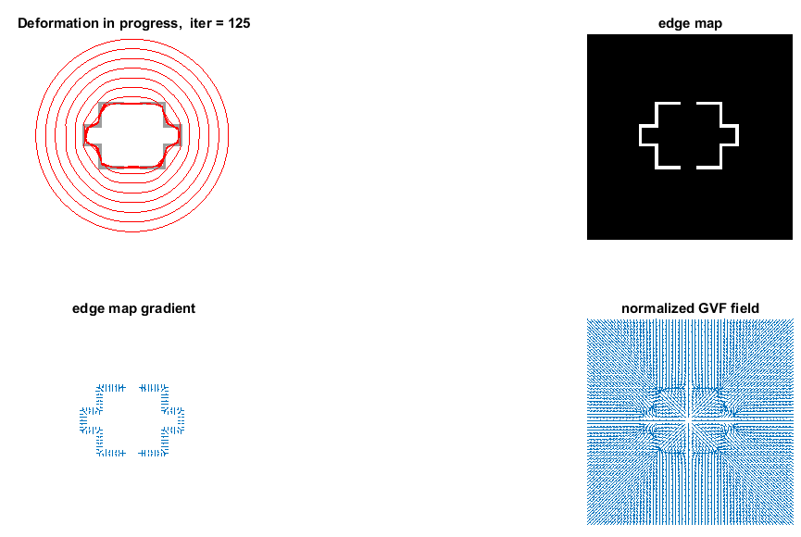

Figure 4: Segmentation from outer contour

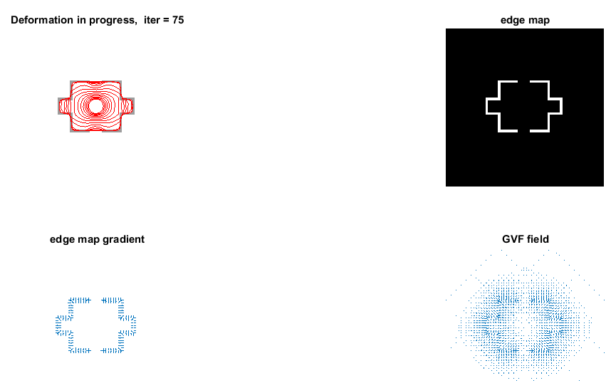

Figure 5: Segmentation from inner boundary

“We have submitted the result of our model, with obtaining test set performance of 79.7%.

The given table below shows the performance of this work with respect to previous works with the methods included in the literature.”

|  |  |
| --- | --- |
| **Method** | **Performance** |
| DeepLab-CRF-LargeFOV-COCO | 72.7 |
| MERL DEEP GCRF | 73.2 |
| CRF-RNN | 74.7 |
| POSTECH DeconvNet CRF VOC | 75.5 |
| BoxSup | 75.7 |
| DeepLab-CRF-Attention | 75.8 |
| CentraleSuperBoundaries++ | 76.0 |
| DeepLab-CRF-Attention-DT | 76.3 |
| H-ReNet + Dense CRF | 76.8 |
| LRR 4x COCO | 77.5 |
| Context CRF + Guidance CRF | 77.8 |
| Adelaide Very Deep FCN VOC | 77.9 |
| Gradient Vector Flow | 79.7 |

Table 2: Comparison table with methods applies earlier

1. **“Conclusion and Future work”**

In this paper we have applied gradient vector flow method for image segmentation. The fields are calculated as the diffusion of the gradient vectors of a grey-level or binary edge map. It allows for the flexible diffusion of the snakes and thus encourages convergence to boundary contours. Some further results for the future prospect are also warranted. In particular, a complete description of the captured ranges of the Gradient vector field will help in snake initialization procedures. It would also help further in fully understanding the GVF parameters, therefore finding a way to choose it optimally for a particular image, and to understand the interplay between gradient and the snake parameters. Finally, the GVF framework for image segmentation might be useful in defining the parameters connected between parametric and geometric snakes.

1. **References**
2. Sonka, Milan, Vaclav Hlavac, and Roger Boyle. *Image processing, analysis, and machine vision*. Cengage Learning, 2014.
3. Jaglan, Poonam, Rajeshwar Dass, and Manoj Duhan. "A Comparative Analysis of Various Image Segmentation Techniques." *Proceedings of 2nd International Conference on Communication, Computing and Networking*. Springer, Singapore, 2019.
4. Kaur, Dilpreet, and Yadwinder Kaur. "Various image segmentation techniques: a review." *International Journal of Computer Science and Mobile Computing* 3.5 (2014): 809-814.
5. Xu, Chenyang, and Jerry L. Prince. "Snakes, shapes, and gradient vector flow." *IEEE Transactions on image processing*7.3 (1998): 359-369.
6. Horn, Berthold KP, and Brian G. Schunck. "Determining optical flow." *Artificial intelligence* 17.1-3 (1981): 185-203.
7. Xu, Chenyang, and Jerry L. Prince. "Gradient vector flow: A new external force for snakes." *Computer Vision and Pattern Recognition, 1997. Proceedings., 1997 IEEE Computer Society Conference on*. IEEE, 1997.
8. Lorensen, William E., and Harvey E. Cline. "Marching cubes: A high resolution 3D surface construction algorithm." *ACM siggraph computer graphics*. Vol. 21. No. 4. ACM, 1987.
9. Xu, Chenyang, and Jerry L. Prince. "Generalized gradient vector flow external forces for active contours1." *Signal processing* 71.2 (1998): 131-139.
10. Willert, Christian E., and Morteza Gharib. "Digital particle image velocimetry." *Experiments in fluids* 10.4 (1991): 181-193.
11. Erkol, Bulent, et al. "Automatic lesion boundary detection in dermoscopy images using gradient vector flow snakes." *Skin Research and Technology* 11.1 (2005): 17-26.
12. Cabral, Brian, and Leith Casey Leedom. "Imaging vector fields using line integral convolution." *Proceedings of the 20th annual conference on Computer graphics and interactive techniques*. ACM, 1993.
13. Zach, Christopher, Thomas Pock, and Horst Bischof. "A duality based approach for realtime TV-L 1 optical flow." *Joint Pattern Recognition Symposium*. Springer, Berlin, Heidelberg, 2007.
14. Bertalmio, Marcelo, et al. "Image inpainting." *Proceedings of the 27th annual conference on Computer graphics and interactive techniques*. ACM Press/Addison-Wesley Publishing Co., 2000.
15. Thirion, J-P. "Image matching as a diffusion process: an analogy with Maxwell's demons." *Medical image analysis* 2.3 (1998): 243-260.
16. Paragios, Nikos, Olivier Mellina-Gottardo, and Visvanathan Ramesh. "Gradient vector flow fast geodesic active contours." *Proceedings Eighth IEEE International Conference on Computer Vision. ICCV 2001*. Vol. 1. IEEE, 2001.
17. Kang, Henry, Seungyong Lee, and Charles K. Chui. "Coherent line drawing." *Proceedings of the 5th international symposium on Non-photorealistic animation and rendering*. ACM, 2007.
18. Boykov, Yuri Y., and M-P. Jolly. "Interactive graph cuts for optimal boundary & region segmentation of objects in ND images." *Computer Vision, 2001. ICCV 2001. Proceedings. Eighth IEEE International Conference on*. Vol. 1. IEEE, 2001.
19. Xu, Chenyang, Dzung L. Pham, and Jerry L. Prince. "Image segmentation using deformable models." *Handbook of medical imaging* 2 (2000): 129-174.
20. Hiremath, P. S., and Jagadeesh Pujari. "Content based image retrieval using color, texture and shape features." *Advanced Computing and Communications, 2007. ADCOM 2007. International Conference on*. IEEE, 2007.
21. Li, Chunming, et al. "Minimization of region-scalable fitting energy for image segmentation." *IEEE transactions on image processing: a publication of the IEEE Signal Processing Society* 17.10 (2008): 1940.
22. Ma, Wei-Ying, and Bangalore S. Manjunath. "EdgeFlow: a technique for boundary detection and image segmentation." *IEEE transactions on image processing* 9.8 (2000): 1375-1388.
23. Blanz, Volker, and Thomas Vetter. "A morphable model for the synthesis of 3D faces." *Proceedings of the 26th annual conference on Computer graphics and interactive techniques*. ACM Press/Addison-Wesley Publishing Co., 1999.
24. Zhang, Kaihua, et al. "Active contours with selective local or global segmentation: a new formulation and level set method." *Image and Vision computing* 28.4 (2010): 668-676.
25. Litwinowicz, Peter. "Processing images and video for an impressionist effect." *Proceedings of the 24th annual conference on Computer graphics and interactive techniques*. ACM Press/Addison-Wesley Publishing Co., 1997.
26. Li, Chunming, et al. "Level set evolution without re-initialization: a new variational formulation." *Computer Vision and Pattern Recognition, 2005. CVPR 2005. IEEE Computer Society Conference on*. Vol. 1. IEEE, 2005.
27. Scarano, Fulvio, and Michel L. Riethmuller. "Iterative multigrid approach in PIV image processing with discrete window offset." *Experiments in Fluids* 26.6 (1999): 513-523.
28. Kearney, Joseph K., William B. Thompson, and Daniel L. Boley. "Optical flow estimation: An error analysis of gradient-based methods with local optimization." *IEEE Transactions on Pattern Analysis and Machine Intelligence* 2 (1987): 229-244.
29. Noll, Douglas C., et al. "A homogeneity correction method for magnetic resonance imaging with time-varying gradients." *IEEE transactions on medical imaging* 10.4 (1991): 629-637.
30. Bertalmio, Marcelo, Andrea L. Bertozzi, and Guillermo Sapiro. "Navier-stokes, fluid dynamics, and image and video inpainting." *Computer Vision and Pattern Recognition, 2001. CVPR 2001. Proceedings of the 2001 IEEE Computer Society Conference on*. Vol. 1. IEEE, 2001.
31. Sadeghian, Farnoosh, et al. "A framework for white blood cell segmentation in microscopic blood images using digital image processing." *Biological procedures online* 11.1 (2009): 196.
32. Boykov, Yuri, and Gareth Funka-Lea. "Graph cuts and efficient ND image segmentation. " *International journal of computer vision* 70.2 (2006): 109-131.
33. Pham, Dzung L., Chenyang Xu, and Jerry L. Prince. "Current methods in medical image segmentation." *Annual review of biomedical engineering* 2.1 (2000): 315-337.
34. Chan, Tony F., B. Yezrielev Sandberg, and Luminita A. Vese. "Active contours without edges for vector-valued images." *Journal of Visual Communication and Image Representation*11.2 (2000): 130-141.
35. Wang, John YA, and Edward H. Adelson. "Representing moving images with layers." *IEEE Transactions on Image Processing* 3.5 (1994): 625-638.
36. Ng, H. P., et al. "Medical image segmentation using k-means clustering and improved watershed algorithm." *Image Analysis and Interpretation, 2006 IEEE Southwest Symposium on*. IEEE, 2006.
37. Li, Chunming, et al. "Distance regularized level set evolution and its application to image segmentation." *IEEE transactions on image processing* 19.12 (2010): 3243.
38. Bradski, Gary R., and James W. Davis. "Motion segmentation and pose recognition with motion history gradients." *Machine Vision and Applications* 13.3 (2002): 174-184.
39. Li, Bing, and Scott T. Acton. "Active contour external force using vector field convolution for image segmentation." *IEEE transactions on image processing* 16.8 (2007): 2096-2106.
40. Bradski, Gary R., and James W. Davis. "Motion segmentation and pose recognition with motion history gradients." *Machine Vision and Applications* 13.3 (2002): 174-184.
41. Levinshtein, Alex, et al. "Turbopixels: Fast superpixels using geometric flows." *IEEE transactions on pattern analysis and machine intelligence* 31.12 (2009): 2290-2297.
42. Ko, Byoung Chul, Ja-Won Gim, and Jae-Yeal Nam. "Automatic white blood cell segmentation using stepwise merging rules and gradient vector flow snake." *Micron* 42.7 (2011): 695-705.
43. Li, Chunming, et al. "A level set method for image segmentation in the presence of intensity inhomogeneities with application to MRI." *IEEE Transactions on Image Processing* 20.7 (2011): 2007.
44. D'hooge, Jan, et al. "Regional strain and strain rate measurements by cardiac ultrasound: principles, implementation and limitations." *European Journal of Echocardiography* 1.3 (2000): 154-170.
45. Perlin, Ken. "An image synthesizer." *ACM Siggraph Computer Graphics* 19.3 (1985): 287-296.
46. Wang, Li, et al. "Active contours driven by local and global intensity fitting energy with application to brain MR image segmentation." *Computerized medical imaging and graphics*33.7 (2009): 520-531.
47. Kang, Henry, Seungyong Lee, and Charles K. Chui. "Flow-based image abstraction." *IEEE transactions on visualization and computer graphics* 15.1 (2009): 62-76.
48. Tang, Jinshan, and Scott T. Acton. "Vessel boundary tracking for intravital microscopy via multiscale gradient vector flow snakes." *IEEE Transactions on Biomedical Engineering* 51.2 (2004): 316-324.
49. Li, Gang, et al. "3D cell nuclei segmentation based on gradient flow tracking." *BMC cell biology* 8.1 (2007): 40.
50. Smith, Stephen M., et al. "Advances in functional and structural MR image analysis and implementation as FSL." *Neuroimage* 23 (2004): S208-S219.
51. Gu, Xuejun, et al. "Implementation and evaluation of various demons deformable image registration algorithms on a GPU." *Physics in Medicine & Biology* 55.1 (2009): 207.
52. Kim, Junmo, et al. "A nonparametric statistical method for image segmentation using information theory and curve evolution." *IEEE Transactions on Image processing* 14.10 (2005): 1486-1502.
53. He, Lei, et al. "A comparative study of deformable contour methods on medical image segmentation." *Image and vision computing* 26.2 (2008): 141-163.
54. Ray, Nilanjan, and Scott T. Acton. "Motion gradient vector flow: An external force for tracking rolling leukocytes with shape and size constrained active contours." *IEEE transactions on medical Imaging* 23.12 (2004): 1466-1478.
55. Michailovich, Oleg, Yogesh Rathi, and Allen Tannenbaum. "Image segmentation using active contours driven by the Bhattacharyya gradient flow." *IEEE Transactions on Image Processing* 16.11 (2007): 2787-2801.
56. Zhou, Peng, and Kenneth E. Goodson. "Subpixel displacement and deformation gradient measurement using digital image/speckle correlation." *Optical Engineering* 40.8 (2001): 1613-1621.
57. Arbelaez, Pablo, et al. "Contour detection and hierarchical image segmentation. " IEEE transactions on pattern analysis and machine intelligence 33.5 (2011): 898-916.
58. Oberhelman, Steven D. "Active Contours Implementation." (2018).
59. Zhang, Rui. "A Gradient Vector Flow Snake Model using Novel Coefficients Setting for Infrared Image Segmentation." *DEStech Transactions on Materials Science and Engineering*icmsme (2016).

|  |
| --- |
|  |
|  |
|  |
|  |  |